Wipro Automation batch 10th march:

22 march 2022

1) create package with name classAndObject:

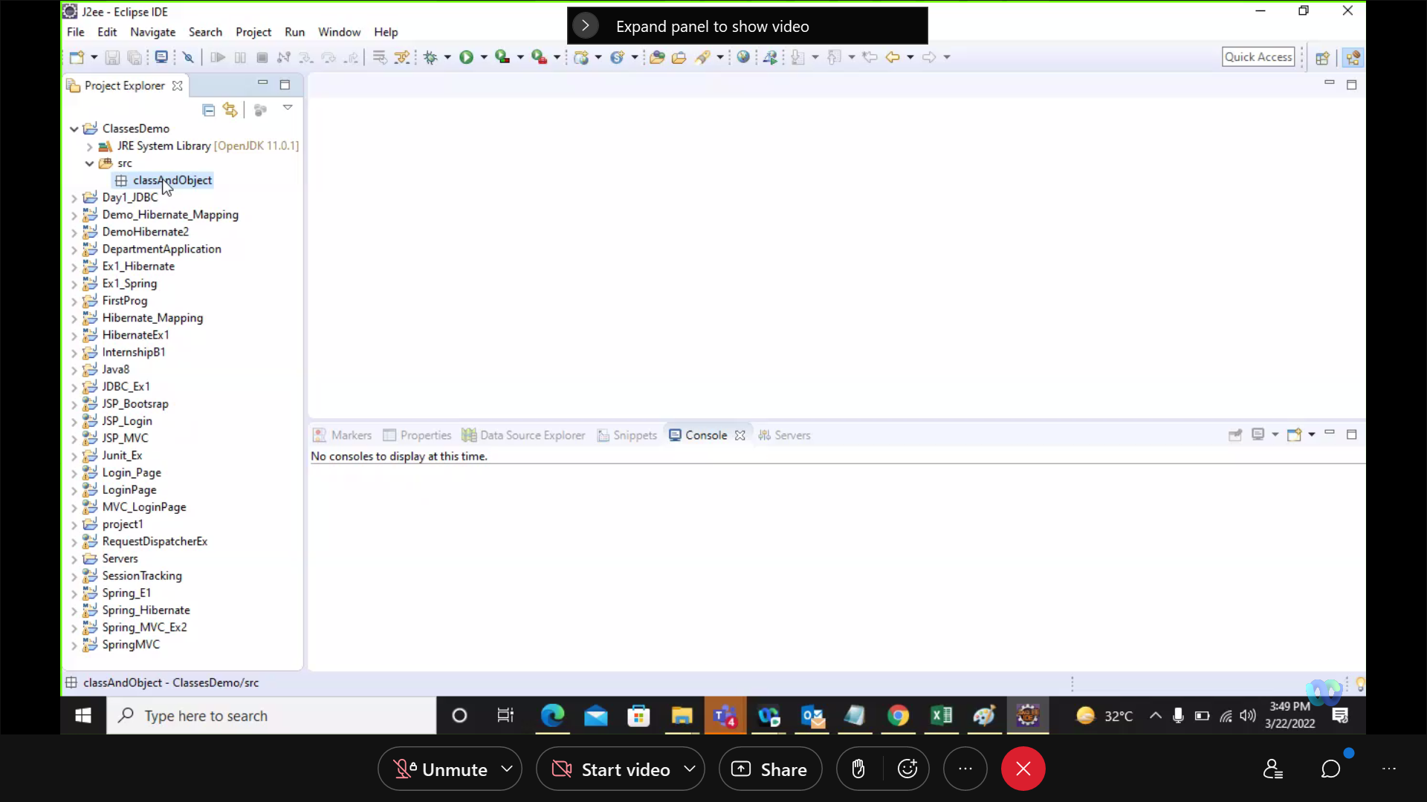

2) create Class name as Calculator:

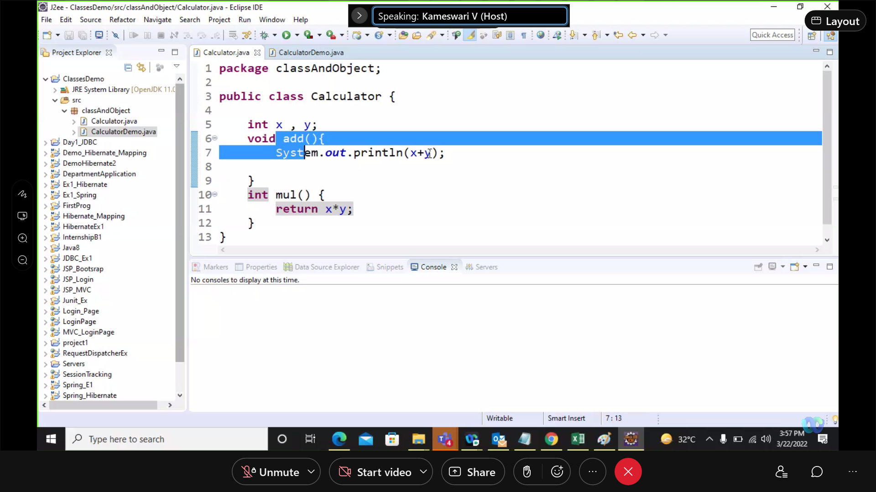

Create another class name as ClassDemo:

C1 is user defined object of Class Calculator:

You can name object as you want for ex c1, c2, c3 etc as many objects you can create as you want.

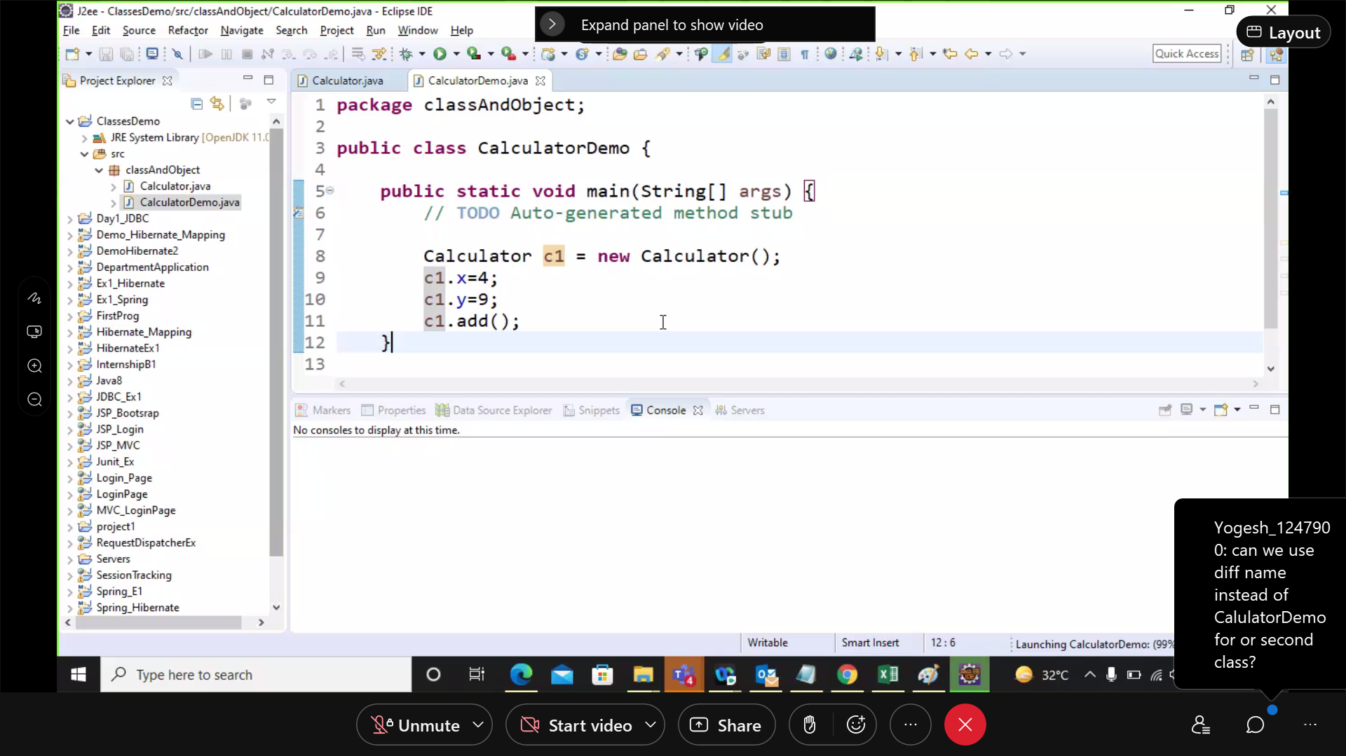

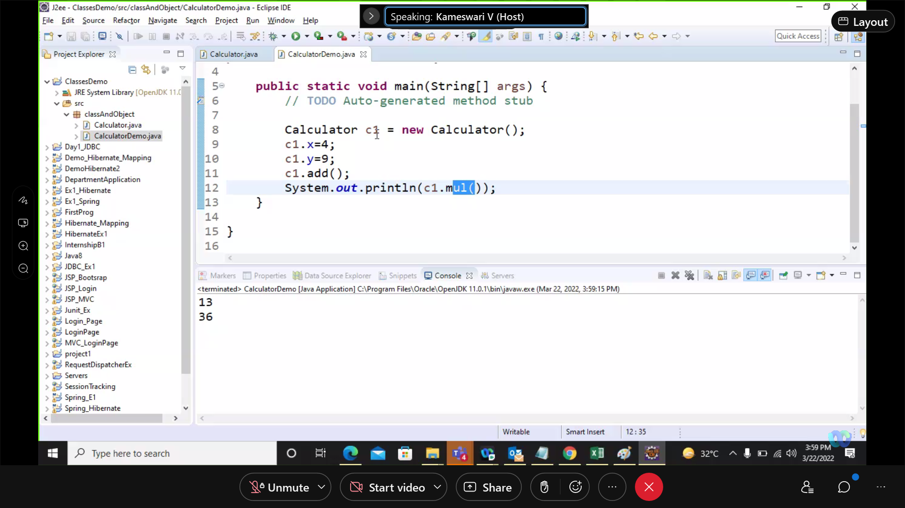

Below we have created another object as name C2 as second object of class Calculator:

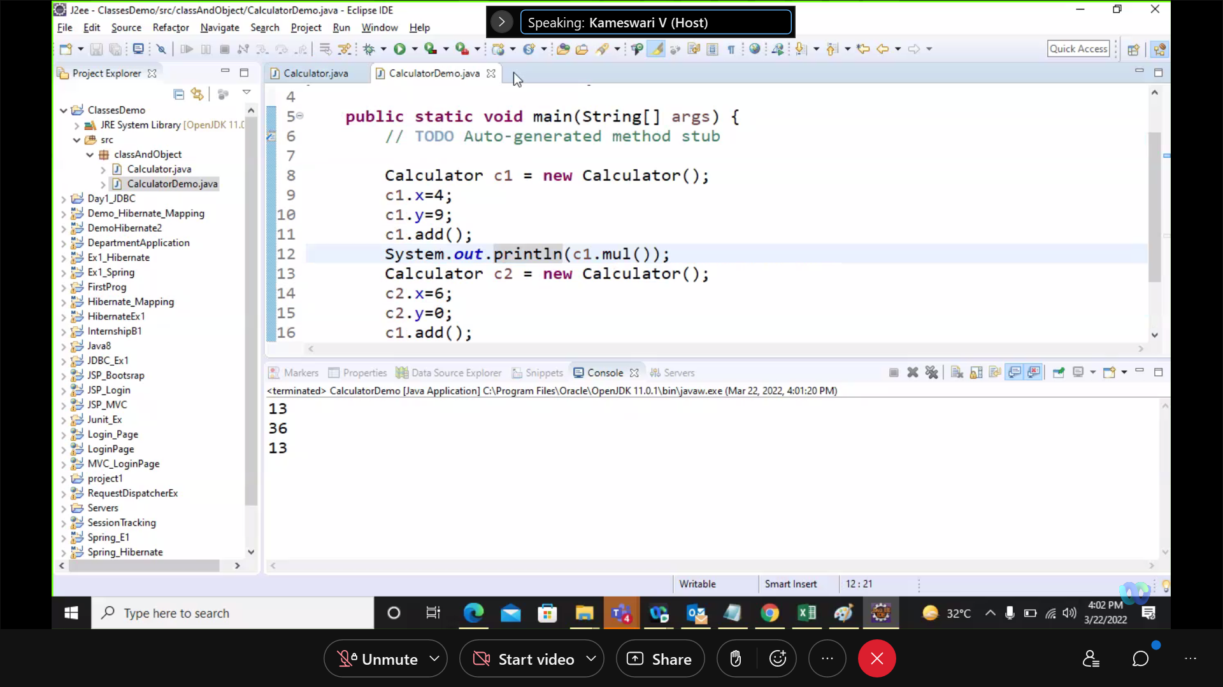

Constructor same as class name:

Constructor will automatically create when program is executed. Empty or default constructor.

Below we have created empty constructor same name as class as Calculator.

We can multiple constructor with different arguments with same name

For ex calculator(int x)

Calculator(int x, int y), calculator(int x, int y, int z)

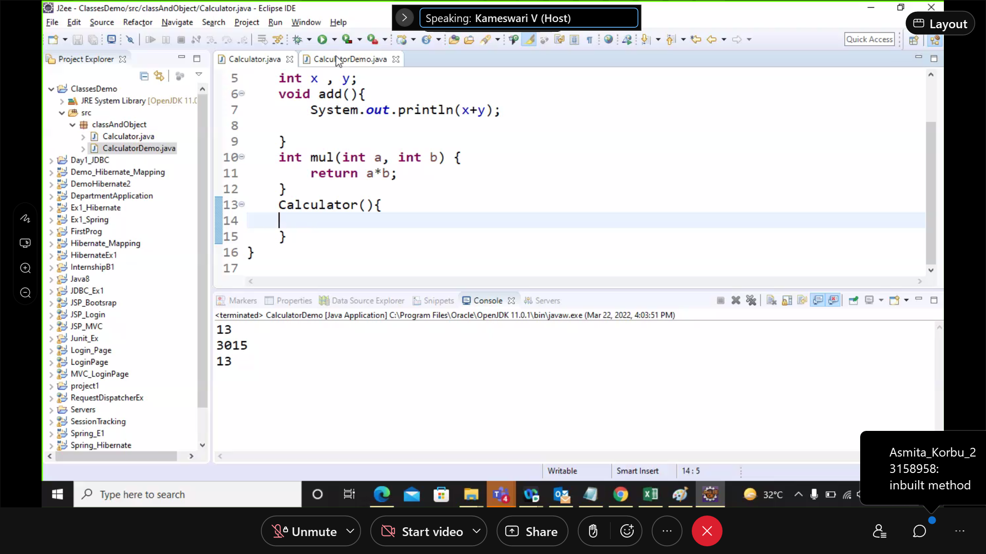

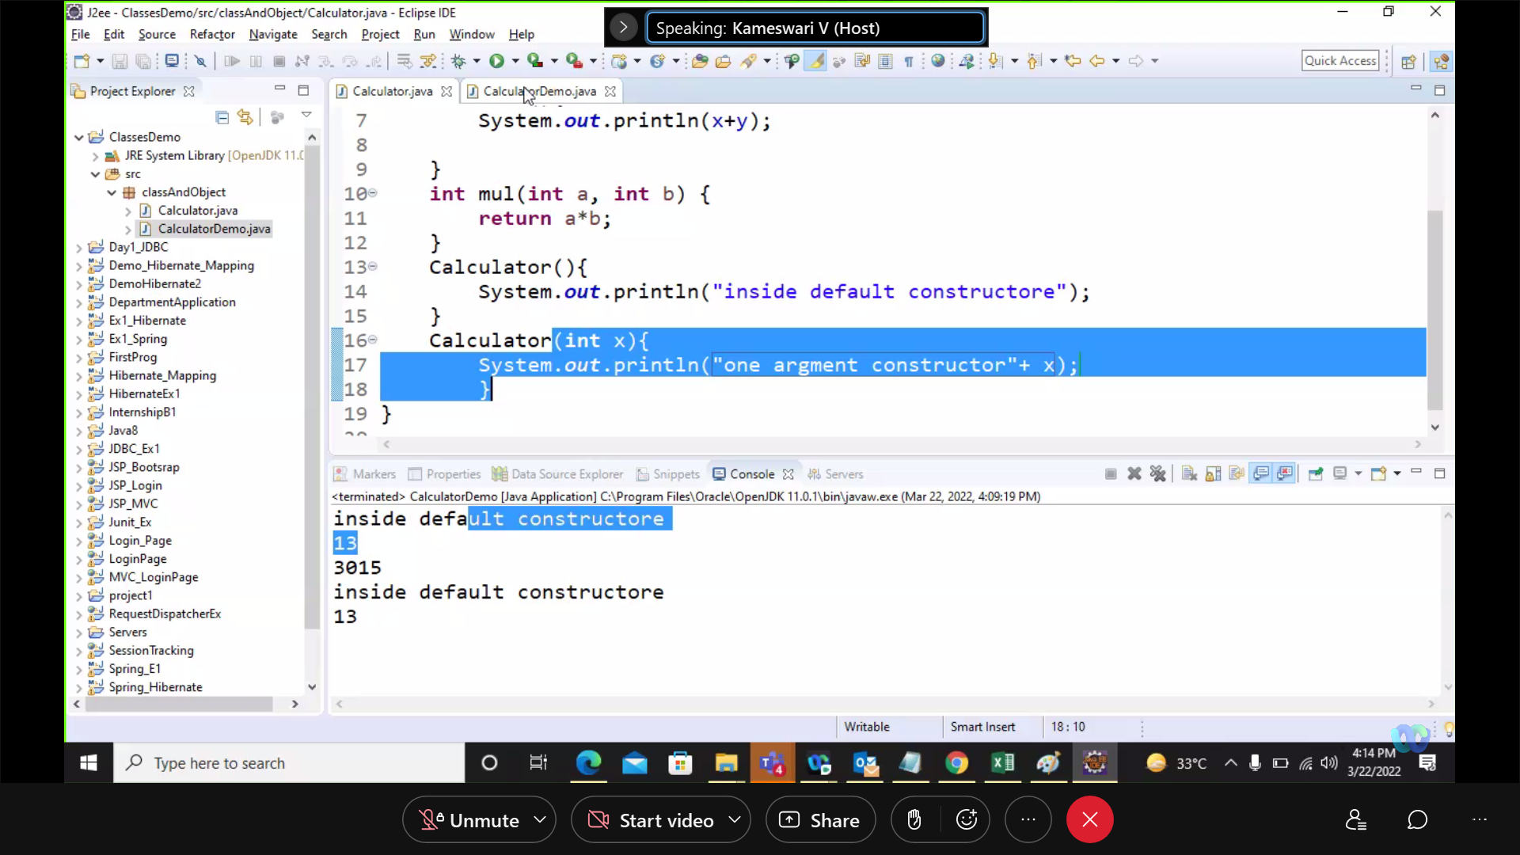

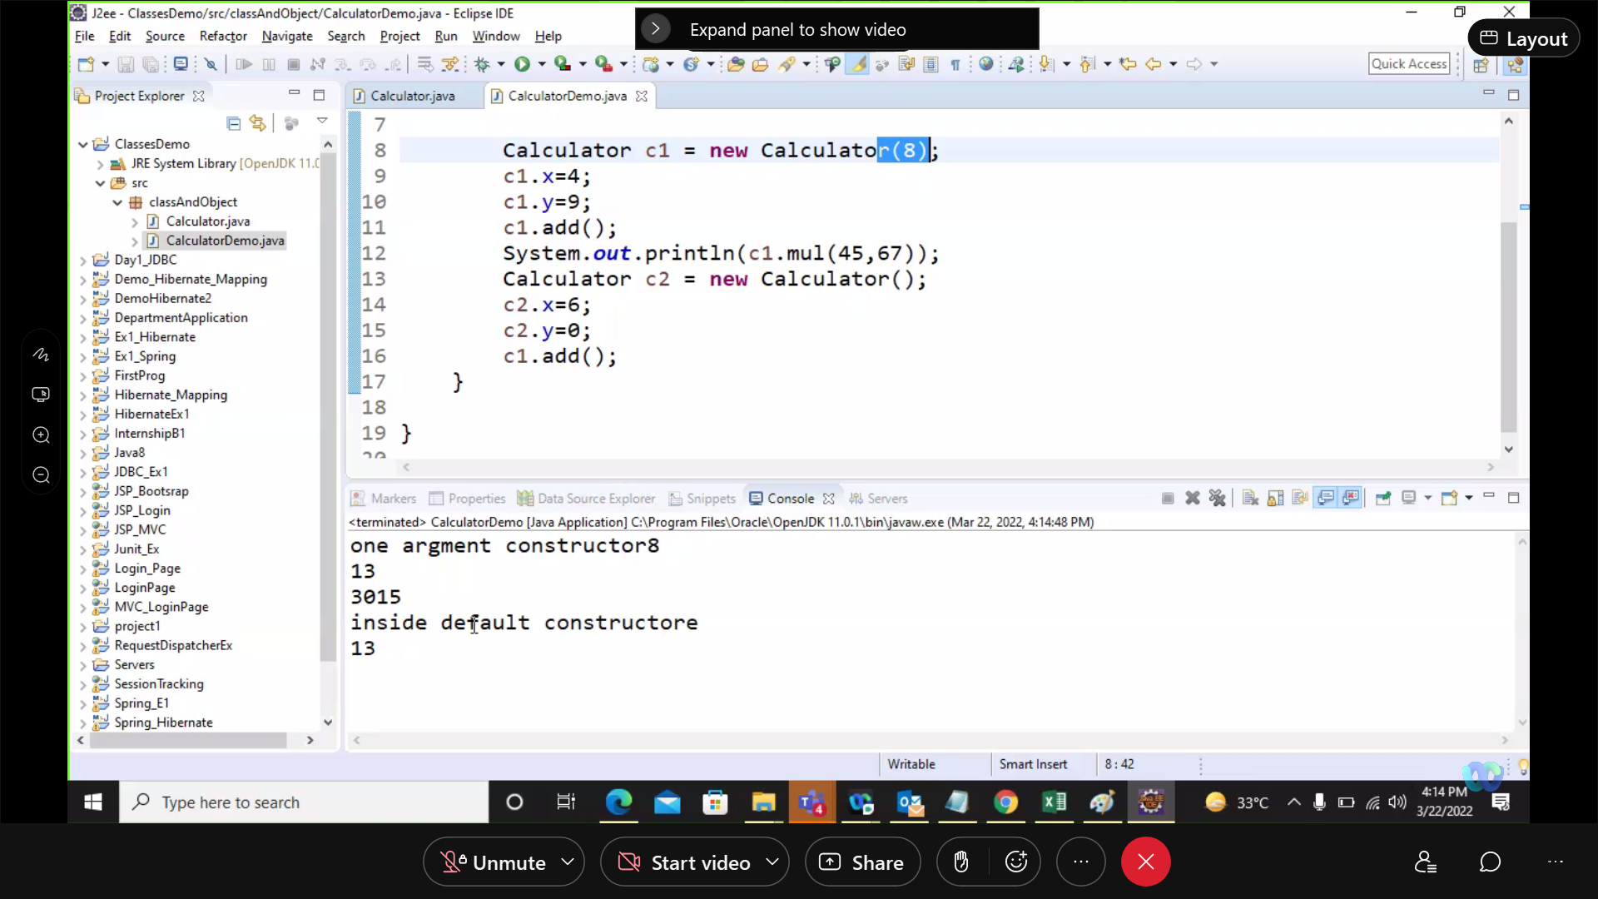

Static variable have only one memory location:

Ex static int z;

C1.z=100;

C2.z=110;

Output: 110 it will return latest value

Static methods: